**ST10019972 – Guillaume Swanevelder**

**ST10019838 – Damian Dare**

**OPSC7311**

**POE Part-1: Planning & Design**

28 March 2024

Table of Contents

1. Introduction 3

2. App Overview 4

3. App Requirements 5

4. The App’s User Interface Design 7

4.1. Login Screen 7

4.2. Sign Up Screen 8

4.3. Time Entries Screen 9

4.4. Entry Creation Screen 10

4.5. Customizer Screen 11

4.6. Category Creation Screen 12

4.7. Statistics Screen 13

4.7.1. Categories Tab 13

4.7.2. Daily Hours Tab 14

4.8. Screen Navigation 15

5. Project Plan 16

6. Conclusion 17

7. References 18

# Introduction

Welcome back!

This document builds upon the extensive research conducted in our research document. This research examined the strengths, weaknesses, and innovative aspects of leading time tracking software, pinpointing crucial features and improvements in user experience. We seek to use this acquired knowledge to integrate the most effective methods and distinctive characteristics into our application, so that we can fill existing market gaps. This fundamental research guarantees that the development of our application prioritises user needs, emphasising functionality, user-friendliness, and cutting-edge features to improve efficiency and user interaction.

This document is divided into 4 sections being “App Overview”, “App Requirements”, “The App’s User Interface Design”, and “Project Plan”. The “App Overview” overviews our application, describing the innovative features we aim to include. The “App Requirements” explores, in detail, the requirements needed for the app to be built. The “The App’s User Interface Design” depicts and explains the various screens of our application via the use of mockups, additionally showing how users may navigate between the screens. Finally, the “Project Plan” details and displays the deadlines and milestones for our project in the form of a Gantt chart.

# App Overview

This is ChronoMetron, a meticulously designed time tracking Android application aimed at transforming time tracking with its user-focused design and functionality. ChronoMetron will distinguish itself by integrating key features from existing time tracking apps alongside implementing a few new features that the time tracking space has never seen before. Some of the innovative features planned for ChronoMetron include:

1. **Archiving:** This feature will allow users to archive and store their time entries elsewhere, keeping a record of time entries instead of deleting them.
2. **Customization:** This will allow users to customize the app to their needs, allowing them to use the app the way they want to. Some of the customizability features include colours, date and time formats, and notification settings.
3. **Notifications:** Users can optionally receive push notifications that will remind them to track their time and stick to their goals, encouraging them along their journey.
4. **Billing:** Users can mark time entries as billable in order to better sort and identify which entries generate revenue.
5. **Favouritism:** Users can mark time entries as a favourite, allowing them to quickly find and access their most used time entries.

The initial icon design and meaning of the name ChronoMetron are presented below:

Figure 1: The initial icon for ChronoMetron

The term "ChronoMetron" is a combination of the terms "Chrono" and "Metron”. “Chrono”, stemming from the Greek word “chronos”, means time (Merriam-Webster, n.d.). The term “Metron”, also stemming from Greek origin, means measure or meter (Merriam-Webster, n.d.). The name ChronoMetron was carefully selected as it represents the accurate measurement and control of time, emphasising its objective to assist users in efficiently arranging their schedules, monitor their activities, and enhance their productivity and time management skills.

# App Requirements

The requirements needed to build the app, based on the research, are as follows:

1. **User Authentication:** Implement a secure login system with multi-factor authentication. Users must be able to register, login, and recover passwords through email verification. This ensures that user data is securely accessed across devices. Implement account recovery through a secure email verification process, including CAPTCHA for bot protection (Silverfort, n.d.). Additionally, users must not be able to use the application without being logged in to an account.
2. **Timesheet Categories:** Users must be able to create and customise categories for their tasks. Some example categories could include “work”, “personal”, and “study”. Utilise a dynamic database schema allowing users to create, modify, and delete custom categories.
3. **Timesheet Entry Creation:** Users must be able to create entries with detailed information such as start and end times, the date, a description of the activity, and a category that it is assigned to. Include options for recurring entries and reminders. Users must additionally be able to update and delete entries.
4. **Photograph Attachments:** Users must be able to optionally attach photos to timesheet entries for better documentation. This could be useful for capturing receipts, notes, or physical progress on tasks. Use cloud storage for storing images with secure access controls (JCards, n.d.).
5. **Work Hour Goals:** Users must be able to set daily work hour goals, setting a minimum and maximum number of hours. The app should notify users when they are close to reaching their maximum hours and congratulate them upon achieving their minimum hours (Indeed Editorial Team, 2022).
6. **Comprehensive Timesheet Listing:** Users must be able to view a detailed list of all entries within a user-selected timeframe. If photos were stored for entries, users must be able to access them from this list. Include filtering options by date, category, and search functionality for specific entries.
7. **Categorised Time Summation:** Offer analytics that show how much time is spent for each user created category over a user selected period. This should help users analyse and prioritise their tasks more effectively.
8. **Graphical Time Display:** Visualise time data with graphs and charts, showing the daily hours worked across a user selected period. This can help users quickly assess their time distribution.
9. **Goal Adherence Display:** Visual indicators or progress bars must be shown to users to inform them how well they are adhering to their set goals. Include motivational messages to encourage productivity and well-being.
10. **Cloud-based Data Storage:** Ensure that all user data is securely stored in the cloud, allowing for access from any device. Consider implementing data encryption and regular backups to prevent data loss.
11. **Notifications:** Users must be able to optionally receive push notifications that remind them to track time, warn them when they get close to their maximum hours, encourage them to meet their minimum goals, and congratulate them when they reach their minimum hours. This is important as it will help users to stick to what they intend to be doing.
12. **Customization:** Users must have the ability to optionally customise the colour of the app, the theme of the app, the format of the dates and times being displayed, and their notification settings. This will enable better user experience as they will be able to use the app their way.
13. **Archiving:** Users must be able to optionally archive time entries. This will help reduce clutter on the list of time entries, allowing for users to quickly access their most important entries. Additionally, if users don’t want to delete an entry, archiving will allow them to store it elsewhere, acting as a reminder to what they have accomplished.
14. **Favoritism:** Users must be able to mark time entries as a favourite, hoisting that entry to the top of the time entry list. This will enable users to quickly find and access their most desired entries, allowing them to easily continue their work. Additionally, this helps with sorting time entries.
15. **Billing:** Users must be able to mark time entries as billable. This will allow users to quickly identify and track the time that is used to generate revenue.

These elaborated requirements provide a clear roadmap for developing the ChronoMetron app, focusing on user engagement, security, and personalised productivity enhancement.

# The App’s User Interface Design

## Login Screen

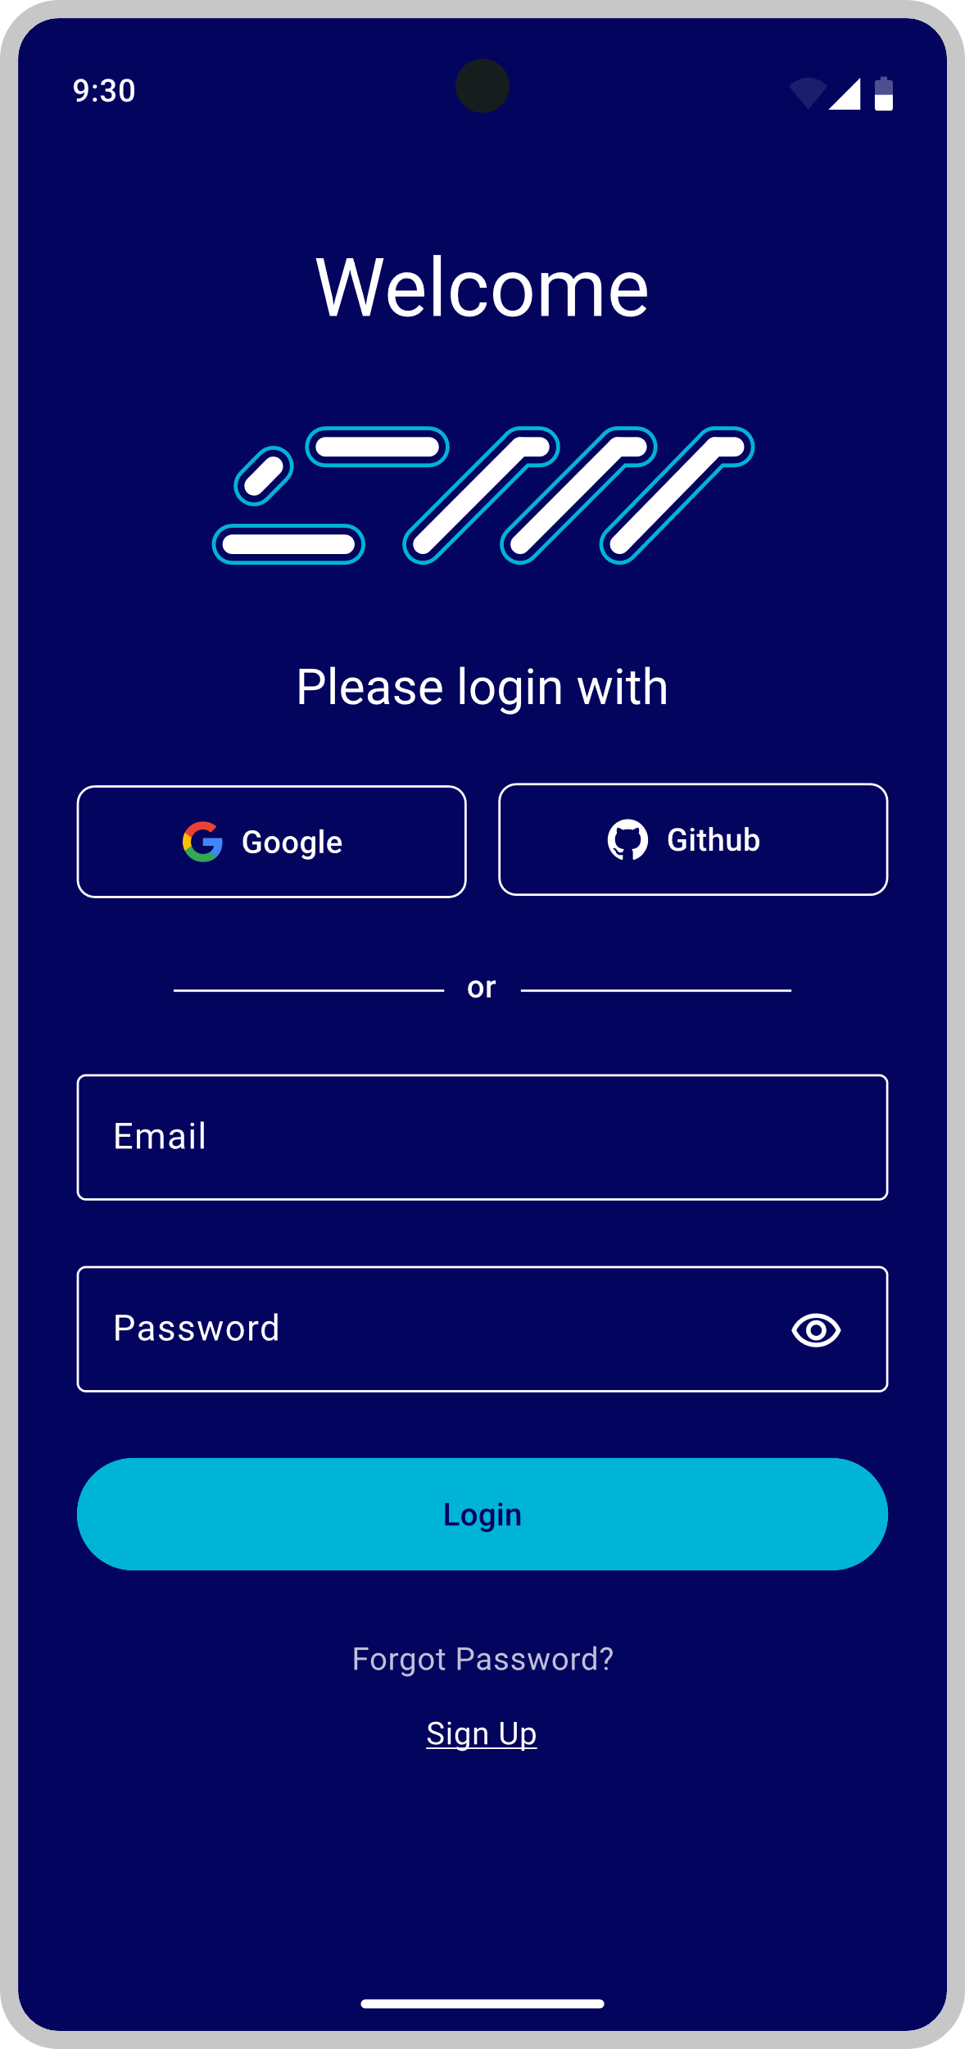

Figure 2: Login Screen

The purpose of this screen is to allow users to securely log in to their accounts by either using their email and password or by using their Google or GitHub accounts. The integration with these services streamlines the login process, offering users a quick and easy access method while maintaining security standards. Additionally, this screen prevents users who don’t have an account from accessing the application.

## Sign Up Screen

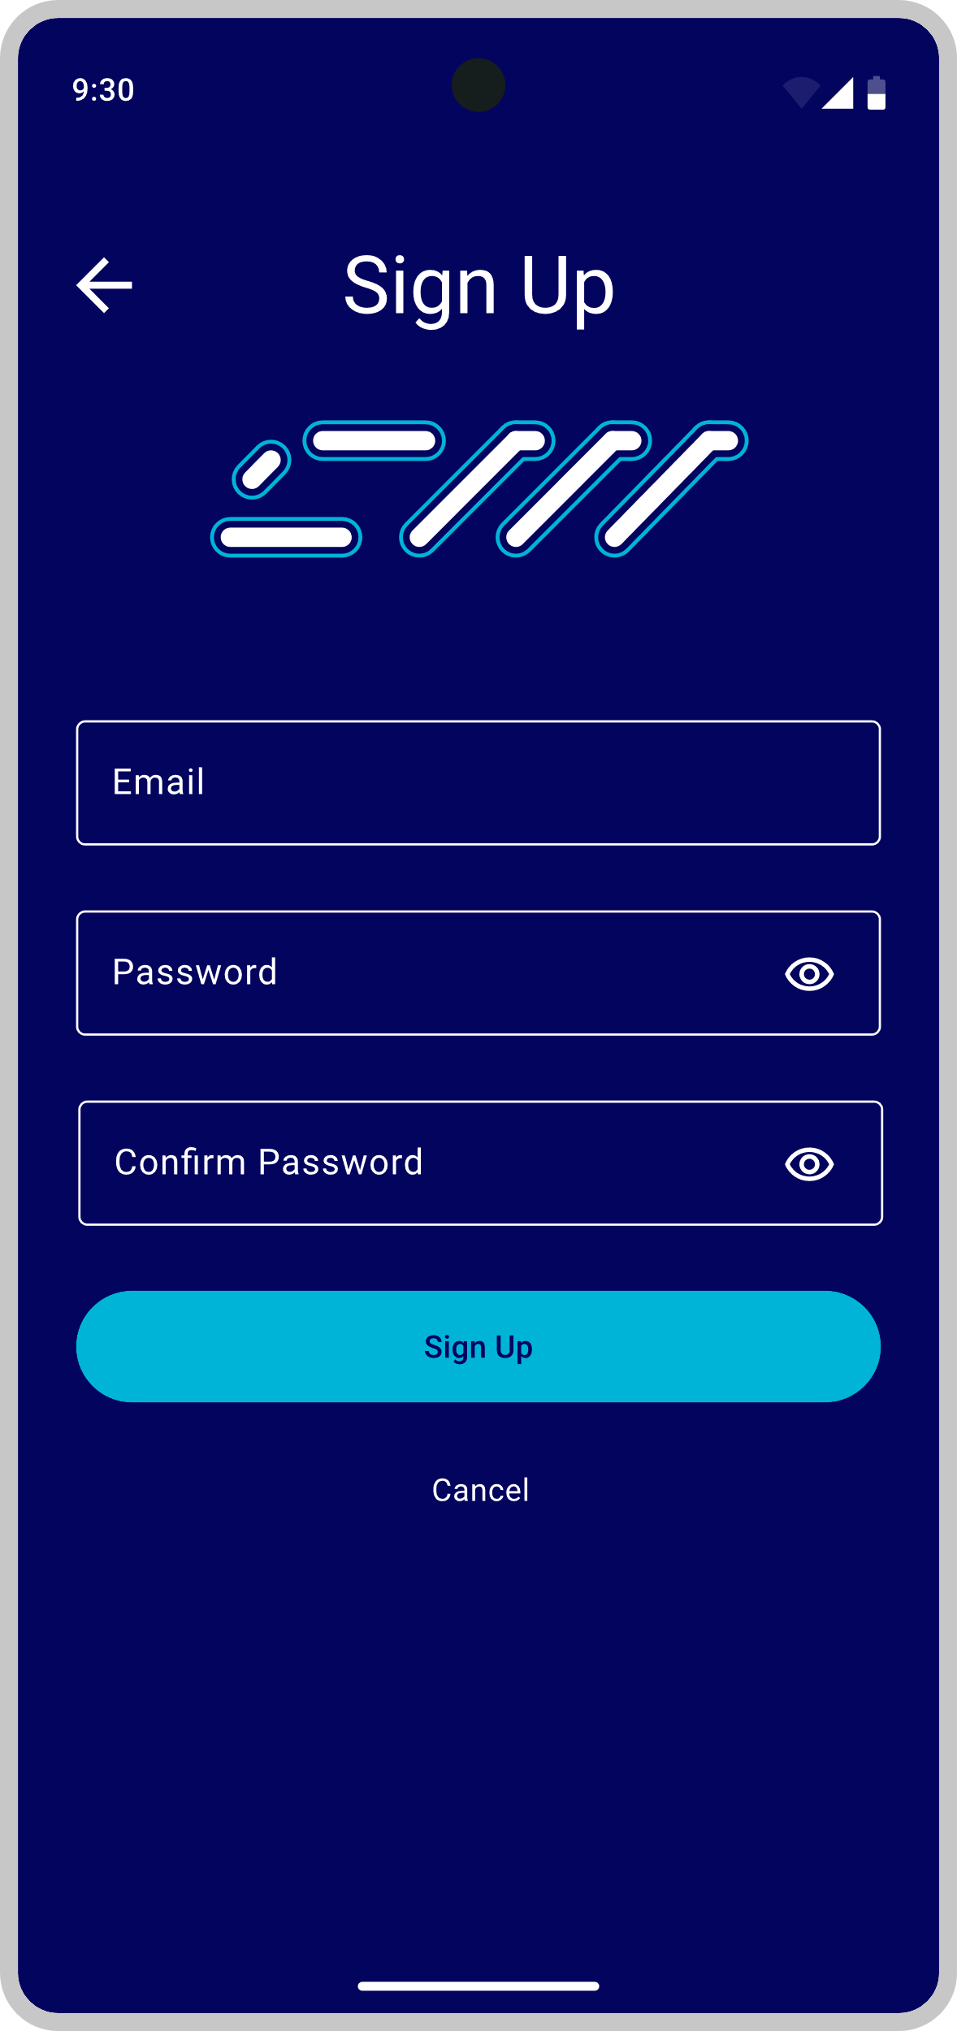

Figure 3: Sign Up Screen

The purpose of this screen is to allow new users to create an account by providing an email, a password, and confirmation of that password. After the account has been successfully created, the user will have access to the application.

## Time Entries Screen

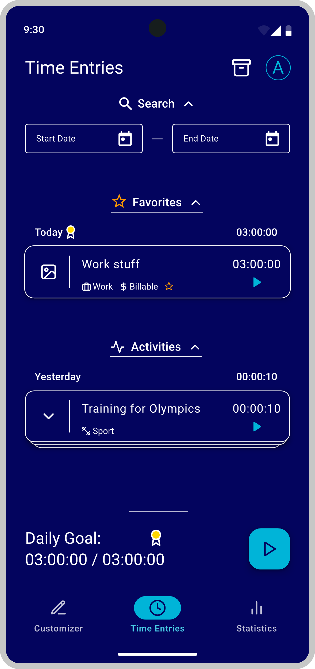

Figure 4: Time Entries Screen

The purpose of this screen is to contain all of the time entry functionality for the user. From here, users can view all their time entries; can edit any of their time entries; can create time entries by clicking on the “plus” button above the navigation bar at the bottom of the screen; can delete time entries by sliding an entry to the left of the screen, then clicking the delete button; can search for time entries between a specific period; can view if they have met their daily goal; and can access archived time entries.

## Entry Creation Screen

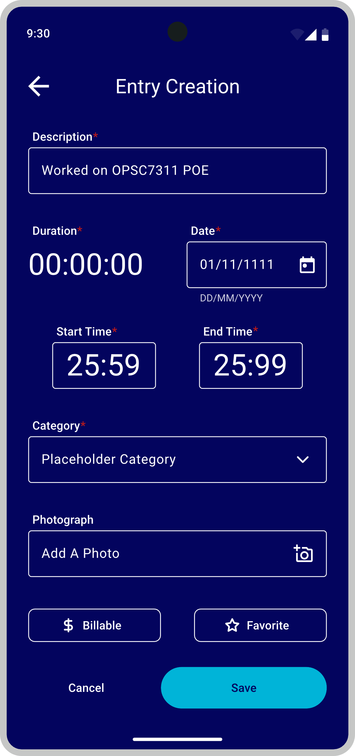

Figure 5: Entry Creation Screen

The purpose of this screen is to create and store time entries. The user is asked to fill in a form and after pressing the save button, a new time entry will be created based on the information the user provided. Some of the form fields are required to fill in, indicated by a red Asterix (*), whereas other fields are optional. The required fields include the “Description”, “Duration”, “Date”, “Start Time”, “End Time”, and “Category” inputs. The optional fields include the “Photograph” input, the “Billable” toggle button, and the “Favourite” toggle button.

## Customizer Screen

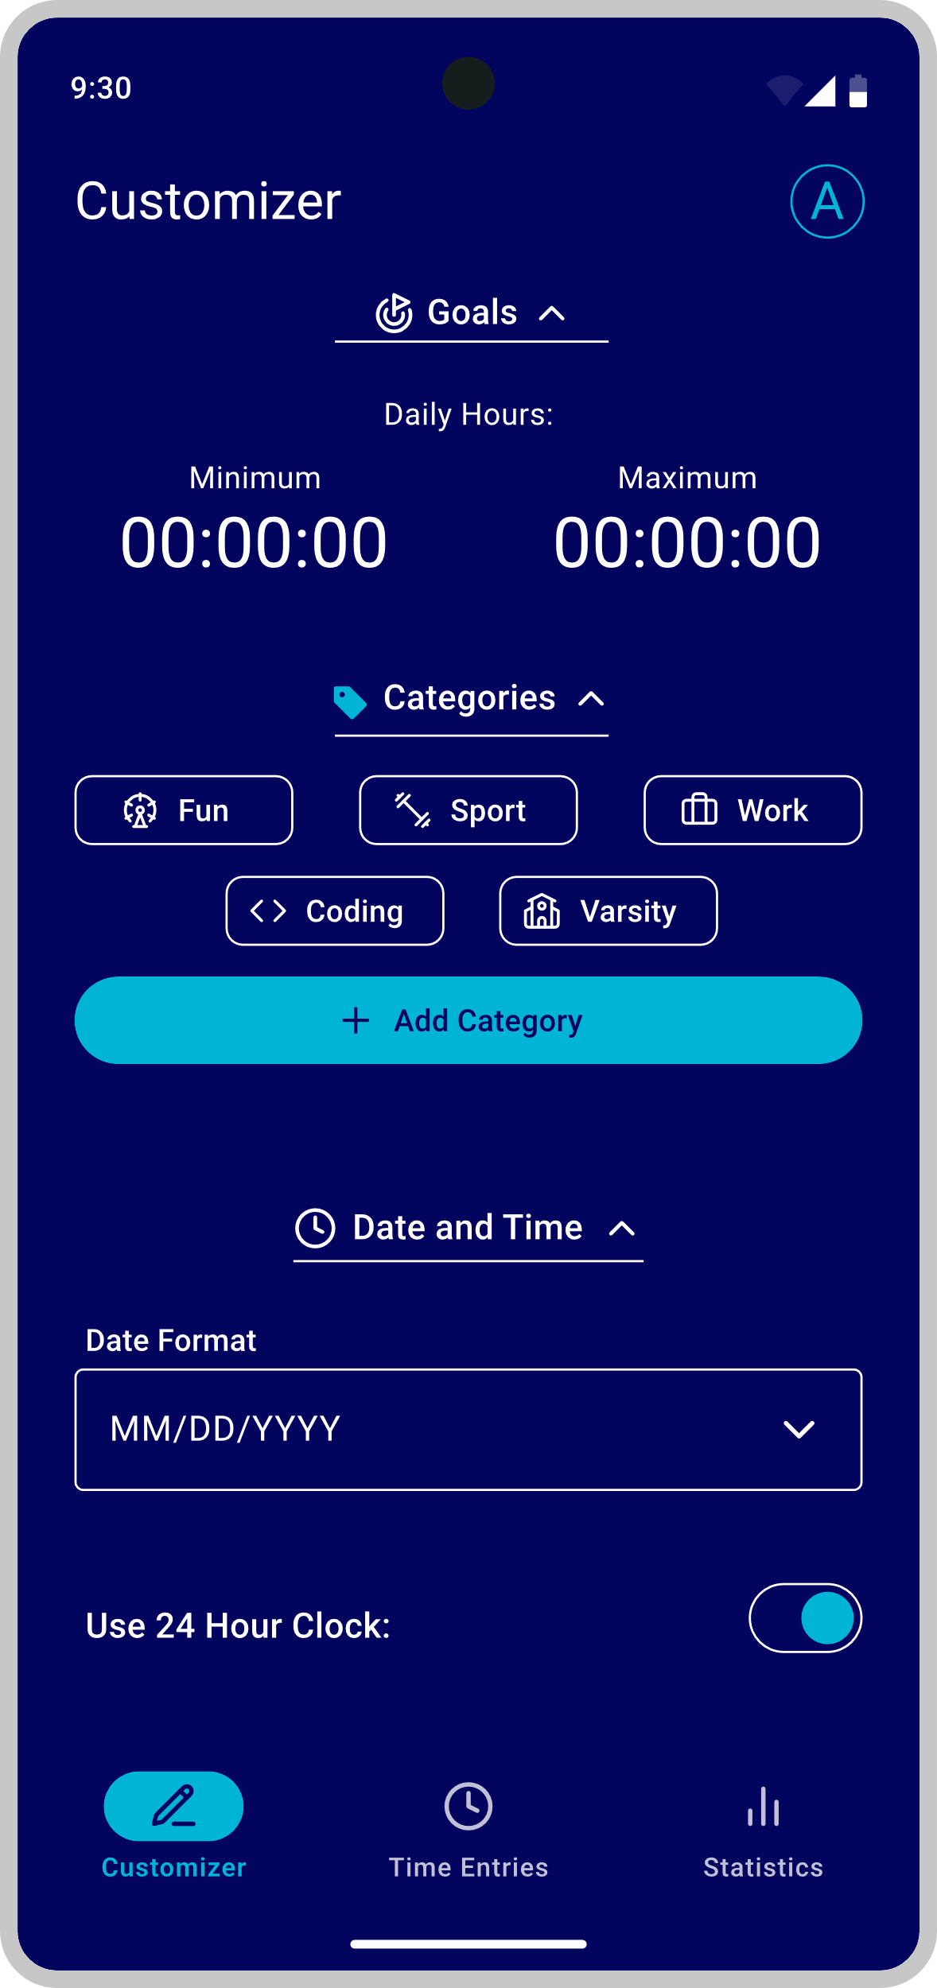

Figure 6: Customizer Screen

The purpose of this screen is to enable the user to customize the app to their needs. From here, users can customize their goals, their timesheet categories, the colour of the app, the theme of the app, the format of the dates and times being displayed, and their notification settings.

## Category Creation Screen

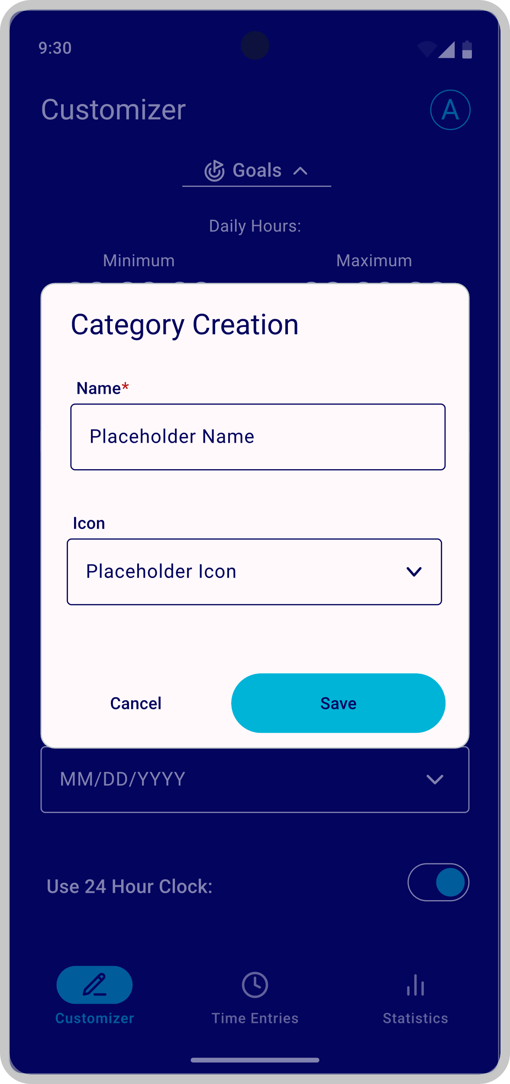

Figure 7: Category Creation Screen

The purpose of this screen is to create and store timesheet categories. In order to create a new category, users must enter a name for that category, and can optionally select an icon to help identify the category.

## Statistics Screen

This screen divides its contents and functionality into two separate tabs that can be accessed by either clicking on the tab itself, or by clicking on the arrow in the direction you wish to navigate towards, moving towards your desired tab, one tab at a time. This was done to allow for a dynamic list of tabs so that in the event that any additional functionality or tabs are needed, there will be room to include it. This list of tabs can be found above navigation bar at the bottom of the screen.

### Categories Tab

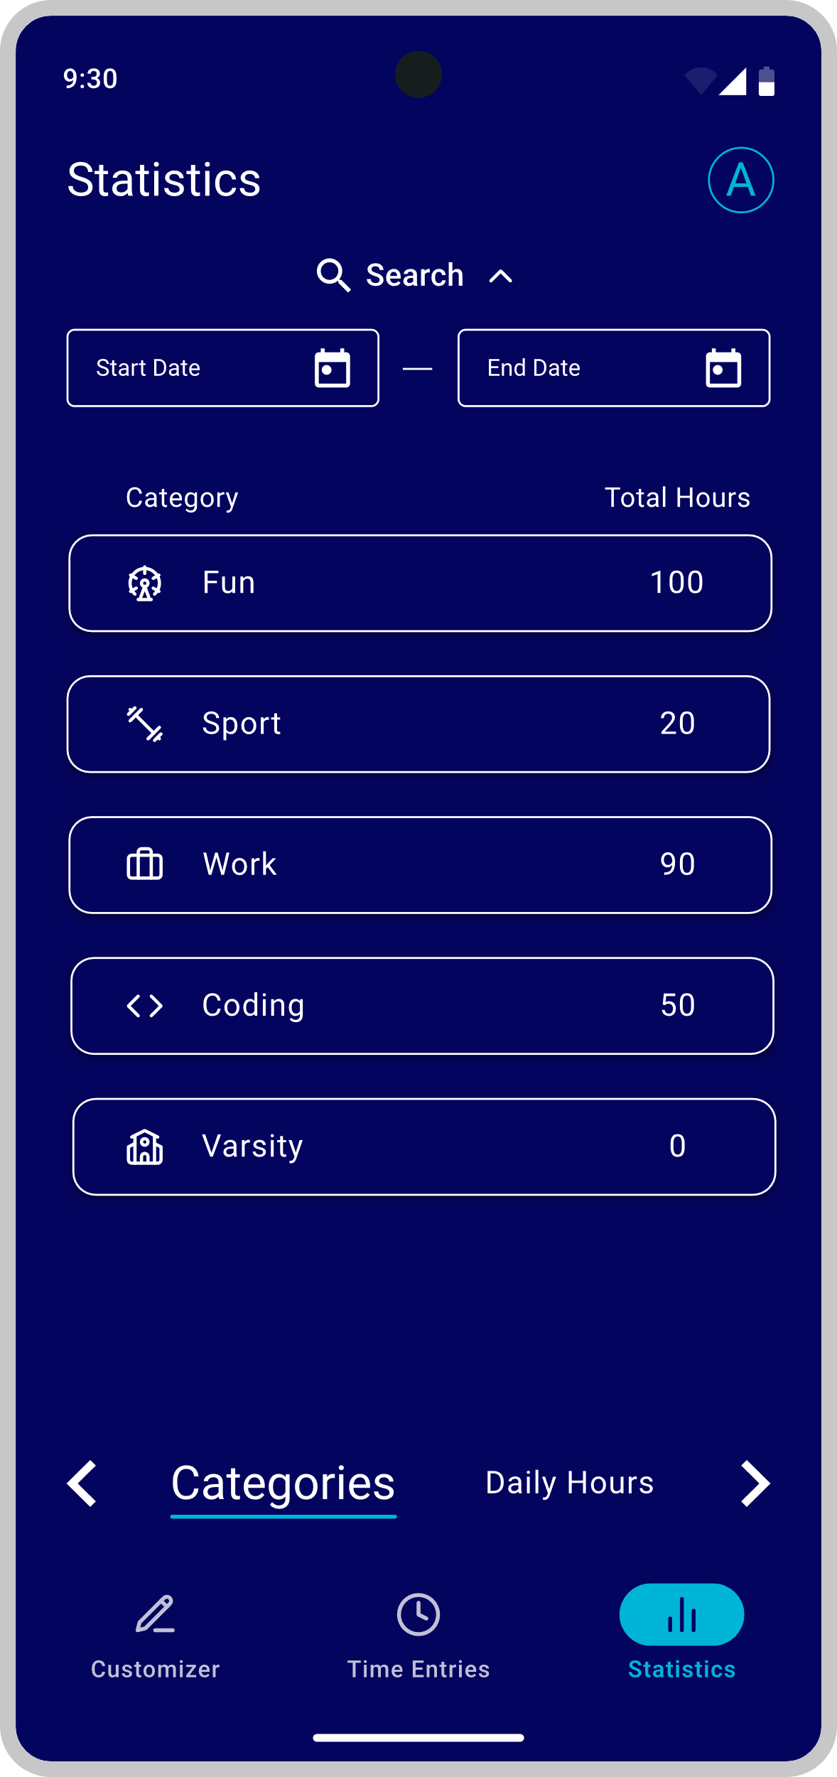

Figure 8: Statistics Screen – Categories Tab

The purpose of this tab/sub-screen is to display to the user, the total number of hours spent on each of their categories during a user selectable period.

### Daily Hours Tab

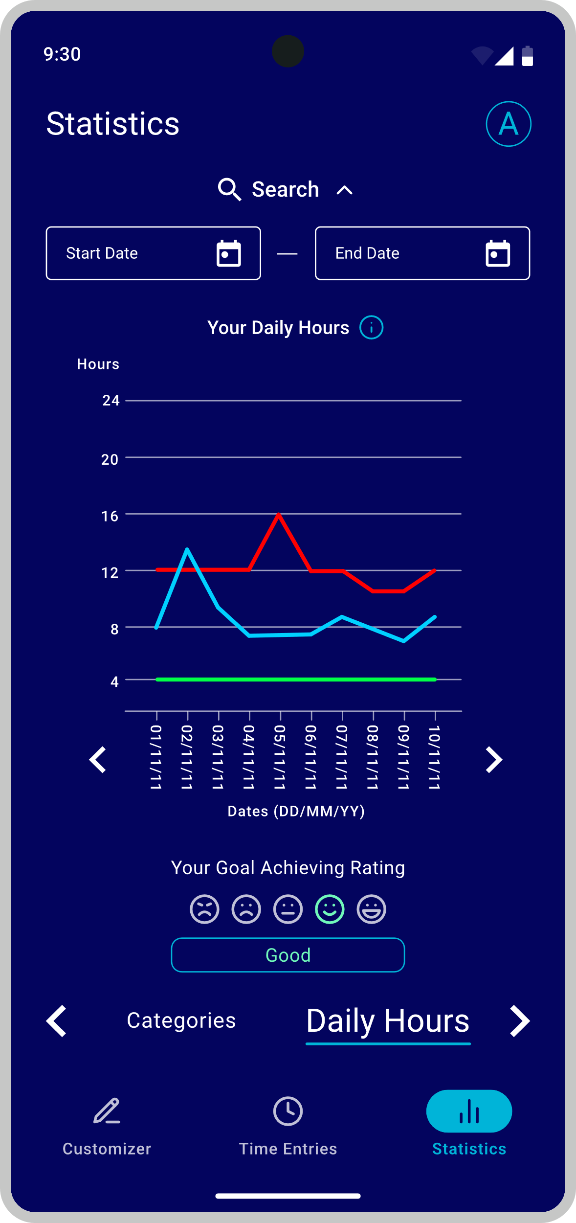

Figure 9: Statistics Screen – Daily Hours Tab

The purpose of this tab/sub-screen is to show the total hours worked each day over a user selected period, in the form of a line graph.

In this line graph, there will be three uniquely coloured lines, being red, cyan, and green. The red line represents the user’s maximum hour goal, the cyan line represents the user’s actual hours worked, and the green line represents the user’s minimum hour goal. This information can be found in the graph’s key, which can be accessed by clicking the “i” icon next to the heading “Your Daily Hours”.

Additionally, underneath the graph, there will be a rating system included to indicate to the user how well they are doing at sticking to their goals. This system uses smiley faces to rate the user. The further right you get, the better the rating, the further left you get, the worse the rating.

## Screen Navigation

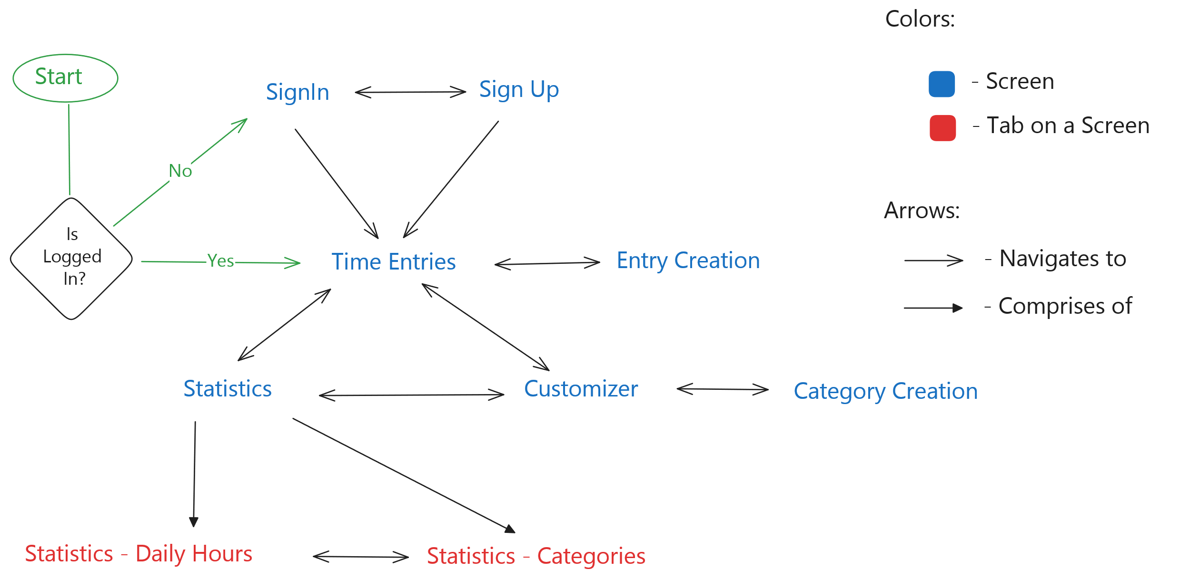

Diagram 1: A diagram of ChronoMetron’s screen navigation

# Project Plan

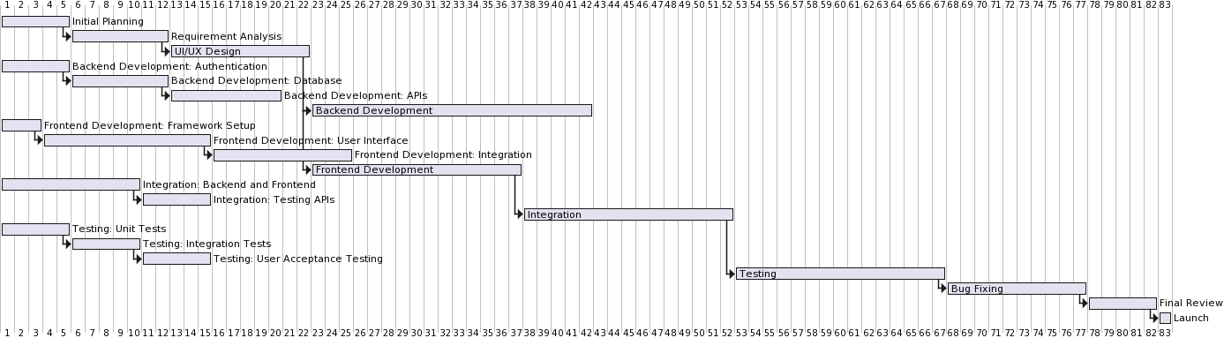

Figure 10: Gantt Chart, Measured in Days, of ChronoMetron Project Plan

# Conclusion

By utilizing the knowledge acquired throughout the research phase, this document was able to address what the project aims at building and how it is going to do it. This document elicited the requirements needed to build our application, depicted how the user interface will look like, depicted how users will navigate throughout the application, and formulated a project plan that will function as a guide to help us complete the project. This document additionally highlighted the projects aim to address current market deficiencies through a design that prioritizes the needs of the user, with a particular focus on functionality, ease of use, and cutting-edge features.

# References

Indeed Editorial Team, 2022. *Time Management Goals To Take Control of Your Time (With Examples).* [Online]   
Available at: https://www.indeed.com/career-advice/career-development/time-management-goals  
[Accessed 13 March 2024].

JCards, n.d. *Time Tracking App With Photo Attachments.* [Online]   
Available at: https://www.jcards.com.au/photo-attachments/  
[Accessed 13 March 2024].

Merriam-Webster, n.d. *Chrono-.* [Online]   
Available at: Merriam-Webster  
[Accessed 25 March 2024].

Merriam-Webster, n.d. *Metron.* [Online]   
Available at: https://www.merriam-webster.com/dictionary/metron  
[Accessed 25 March 2024].

Silverfort, n.d. *Re-evaluate your MFA.* [Online]   
Available at: https://www.silverfort.com/re-evaluate-your-mfa-are-you-as-protected-as-you-should-be/?kw=risk%20based%20authentication%20solutions&cpn=17569335343&utm_term=risk%20based%20authentication%20solutions&utm_campaign=GGL-S-Generic-Broad&utm_source=adwords&utm_  
[Accessed 13 March 2024].